MINI PROJECT I
(Mini-project step 1: Naive, NumPy, Numba)

Shreejal Dahal
Aalborg University, Copenhagen

Numerical Scientific Computing
Mentor: Vasilis Ntinas
2026-03-12

Contents
1. Introduction 3
2. Implementation 4
2.1. Naive Version 4
2.2. Numpy – Vectorized 5
2.3 Numba JIT Compiled 6
3. Benchmarking Methodology 7
3.1. Fixed Parameter 7
3.2. Scaling Benchmark 7
4. Experimental Results 9
4.1. Fixed Parameter Performance (1024x1024, max_iter=100) 9
4.2. Scaling Results (max_iter = 50) 9
4.3. Scaling Exponents 10
5. Reasoning and Interpretation 11
5.1. Why is Naive slow 11
5.2. Why is Numpy faster (but limited) 11
5.3. Why is Numba fastest 11

1. Introduction
The Mandelbrot set is the uncountable set of values of c in the complex plane for which the orbit of the critical point z = 0, under iteration of the quadratic map z^2 + c, remains bounded. Thus, a complex number c is a member of the Mandelbrot set if, when starting with z(0) = 0, and applying the iteration repeatedly, the absolute value of z(n) remains bounded for all n > 0.
A point c in C, belongs to Mandelbrot set if the sequence |z(n)| remains bounded and never exceed 2. The problem here is that, for example, for a 1024x1024 image at 100 iterations which is approximately 100 million operations, makes Mandelbrot set a classic compute-bound problem and an ideal benchmark for comparing Python strategies (optimizations).
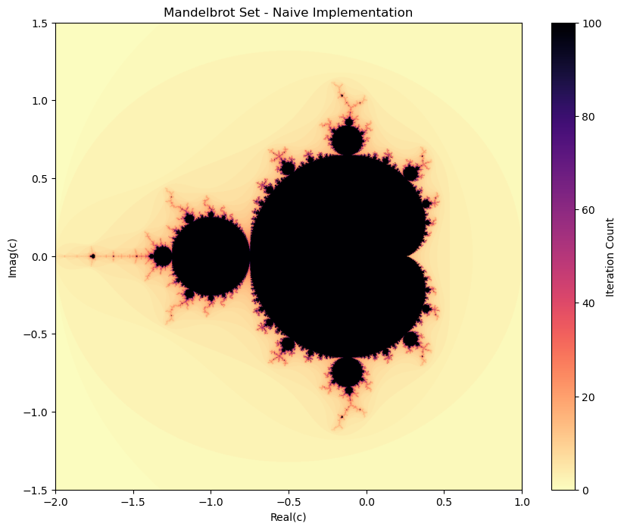
Fig: Mandelbrot Set (magma_r)

2. Implementation

2.1. Naive Version
This is the straight forward translation of the mathematical definition. There are 3 nested for loops for rows, columns and iterations respectively. Each of the opeations passes through the cpython interpreter (bytecode first).
It:
1. Looks up variable type on every step
2. Performs reference counting memory management
3. Executes the byte code one instruction at a time (no vectorization)
The iteration count is stored in numpy array but every individual computation is done by python.
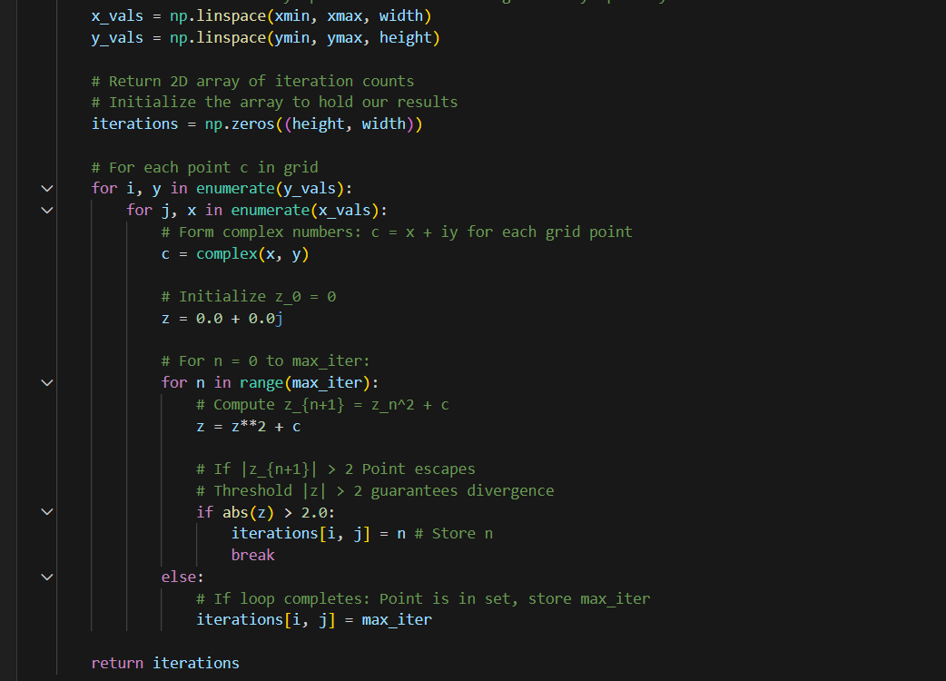
Fig: Naive (Non-Vectorized)

2.2. Numpy – Vectorized
Unlike naive version, instead of iterating over pixels, numpy processes the entire arrays at once, using the pre-compiled C routines inside numpy. This works like this:
- Builds a 2d grid C of all c values in a single broadcast operation
- Iterates outer loop only max_iter times.
- Inside the iterations, applies z <- z^2 + C simultaneously to all the pixels that has not escaped. This uses numpy masked array operations.
- Uses a Boolean mask to track the live pixels and applies an exit (early) if all the points have escaped.
The python for loop over the max_iter is retained but the inner work is delegated to c level numpy kernel.
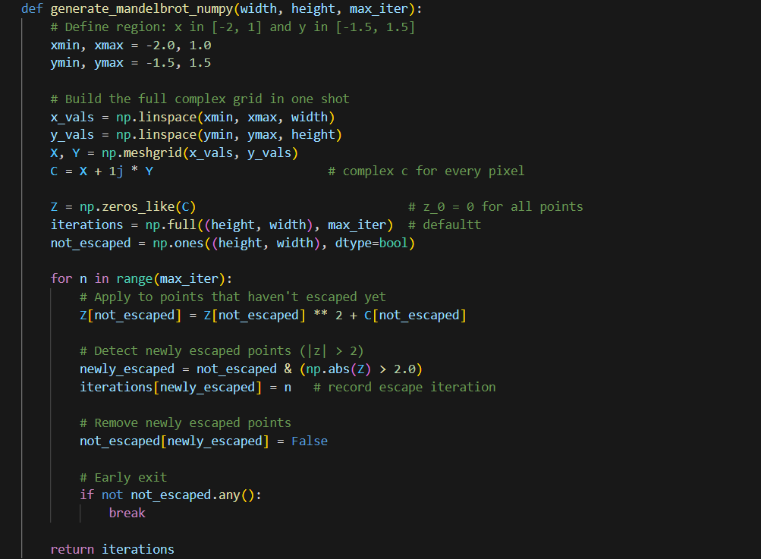
Fig: Numpy Implementation (vectorized)

2.3 Numba JIT Compiled
The decorator, @njit, from the numba library compiles the python func. to native machine code firstly, using the LLVM compiler. So it:
- Has no python interpreter
- Uses statically typed variables (numba infers them from the first call)
- Benefits from LLVM optimizations (loop unrolling, inlining, etc)
- Replaces abs(z)**2 > 4 with its equivalent z.real*z.real + z.imag*z.imag > 4.0. This is to avoid the square root call.
Here, the same nested loop from Naive version is preserved.
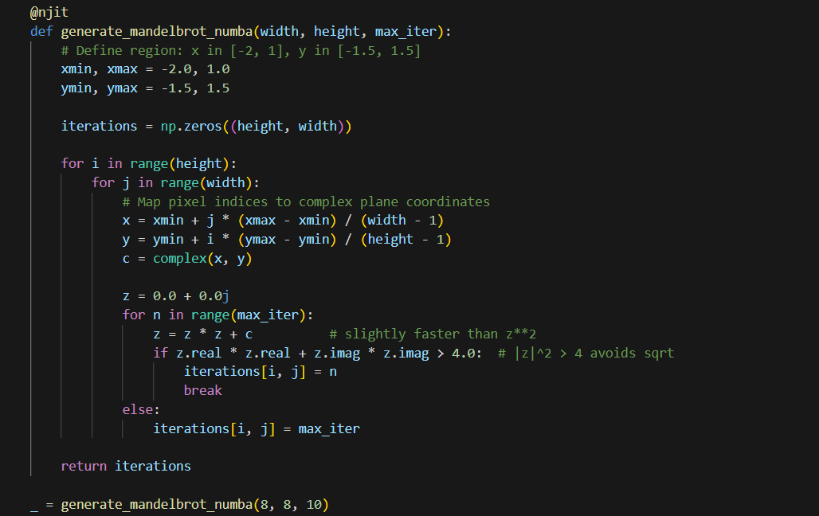
Fig: Numba (njit compiler)

3. Benchmarking Methodology

3.1. Fixed Parameter
Here, each implementation was called 3 times under the identical parameters. The arithmetic mean of three elapsed wall cl. times, measured with time.pref_counter(), the highest resolution timer available in Py, was used as representative figure.
Parameter | Value
Resolution | 1024x1024
Max_iter | 100
Runs per implementation | 3
Statistic report | Arithmetic mean

3.2. Scaling Benchmark
This is to study how each implementations scales with the problem size. The following resolutions were tested:
Resolution | Pixels
256x256 | 65,536
512x512 | 262,144
1024x1024 | 1,048,576
2048x2048 | 4,194,304

For this, the max_iter was set to 50, instead of 100, to keep the total runtime manageable. The naive implementation was skipped, at the last resolution (predicted time: 15 seconds per run, 3 runs)
The scaling exponents were extracted by fitting linear model to log data.
Log(t) = a.log(N) + B, here N is the total pixel count. An exponent a ~ 1.0 is expected (linear in pixel count).

4. Experimental Results

4.1. Fixed Parameter Performance (1024x1024, max_iter=100)
Implementation | Average Time | Speedup vs Naive
Naive | ~6.00 | 1.00 (baseline)
Numpy | ~2.30 | ~2.6x
Numba | ~0.097 | ~61x

Numba is about 25x faster than numpy at this resolution.
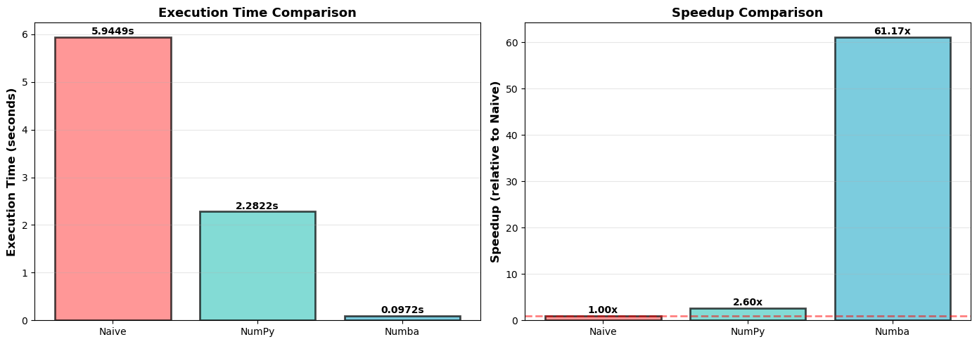
Fig: Execution Time & Speedup Comparision

4.2. Scaling Results (max_iter = 50)
Resolution | Naive | Numpy | Numba
256x256 | 0.23 | 0.04 | 0.004
512x512 | 0.94 | 0.30 | 0.014
1024x1024 | 3.28 | 1.43 | 0.061
2048x2048 | skipped | 4.91 | 0.225

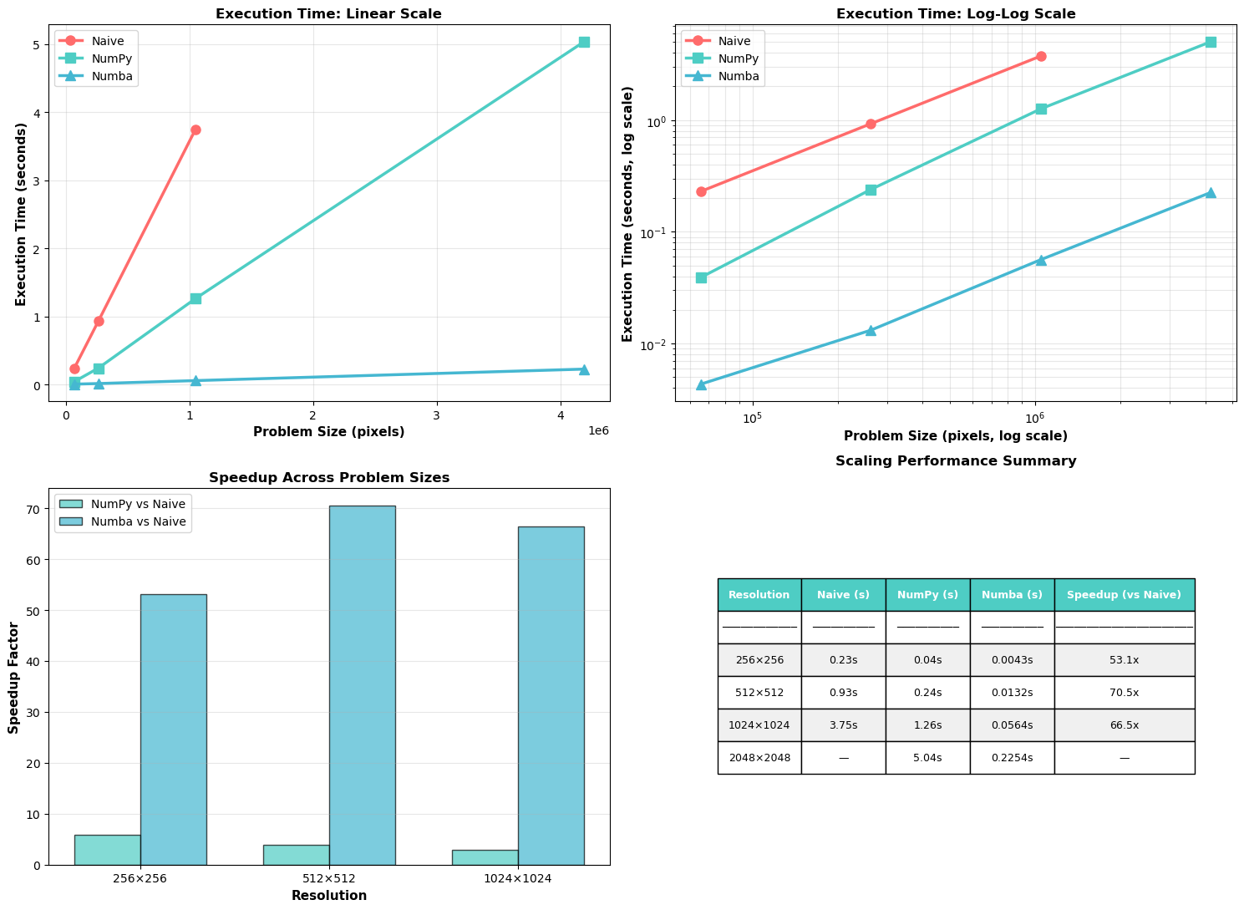
Fig: Scaling Analysis

4.3. Scaling Exponents
All of the three implementations exhibit an exponent of approximately 1 in pixel count, confirming the expected quadratic relationship, i.e., quadrupling the pixel count quadruples the runtime.
Naive Implementation: 1.007 (O(n^1.01))
NumPy Implementation: 1.172 (O(n^1.17))
Numba Implementation: 0.960 (O(n^0.96))

5. Reasoning and Interpretation

5.1. Why is Naive slow
Python, as it is interpreted, dynamically typed language, every arithmetic operation inside innermost loop, z = z**2 +c, requires :
- Byte code dispatched to the interpreter
- Type lookup and method resolution (for, __mul__, __add__, etc)
- Heap allocation of a new Complex object for each of the immediate results
- Reference count update
For example, for a 1024x1024 image at 100 iters, these overheads are paid approximately 100 million times, accumulating to seconds of the cpu time.

5.2. Why is Numpy faster (but limited)
The bottleneck, interpreter is shifted to compiled c code. The single call Z[mask]**2 + C[Mask] dispatches to the tight C loop that operate on a contiguous memory buffer with no per element python overhead. But below this, its limited by mask overhead, redundant work for escaped pixels(are excluded, but updating and broadcasting the mask itself has overhead), python loop retained(outer loop).

5.3. Why is Numba fastest
Numba removes every remaining source of python overhead. After jit compilation the function is executed as its been written in C. The features are:
- No type resolution
- No heap allocation
- LLVM optimization
- Early escape
- Cache friendly access

